**VIETNAM NATIONAL UNIVERSITY - HO CHI MINH CITY**

**INTERNATIONAL UNIVERSITY**

**SCHOOL OF COMPUTER SCIENCE & ENGINEERING**

**INTRODUCTION TO ARTIFICIAL INTELLIGENCE**

Course by Dr. Nguyen Trung Ky

**LAB #6:**

**PERCEPTRON**

Student's Name: Nguyen Duc Nguyen Phuc

Student's ID: ITIDSIU21108

1. **Application to binary classification**

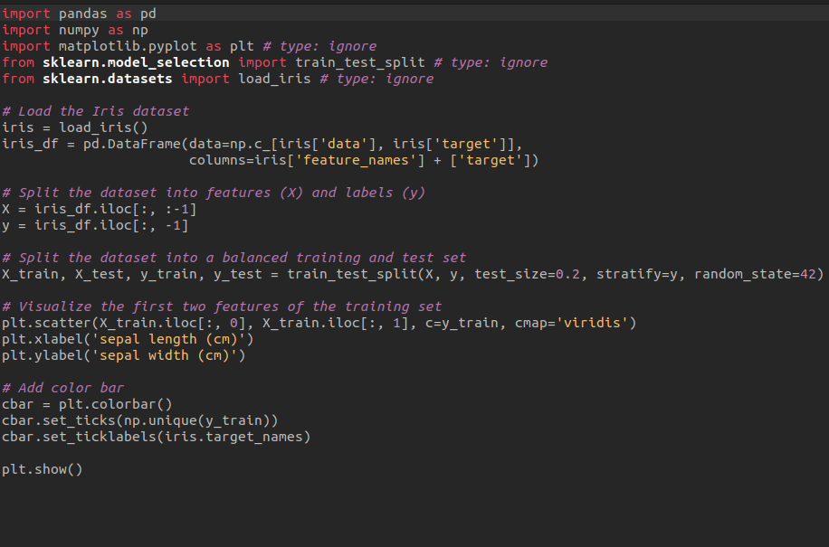

Output:

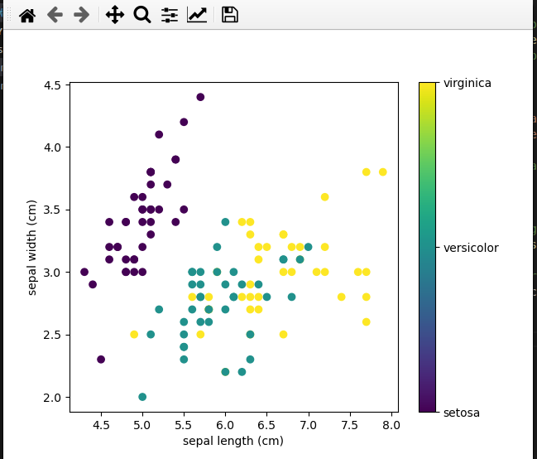

1. **(Optional) Application to multi-label classification**

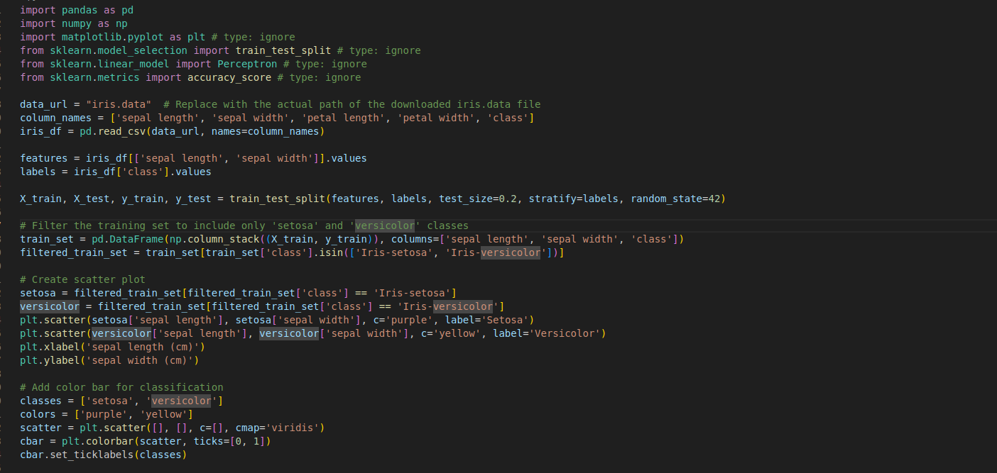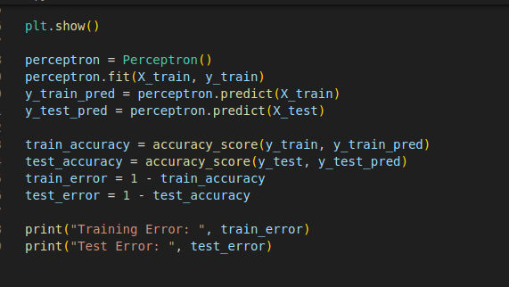

Output:

